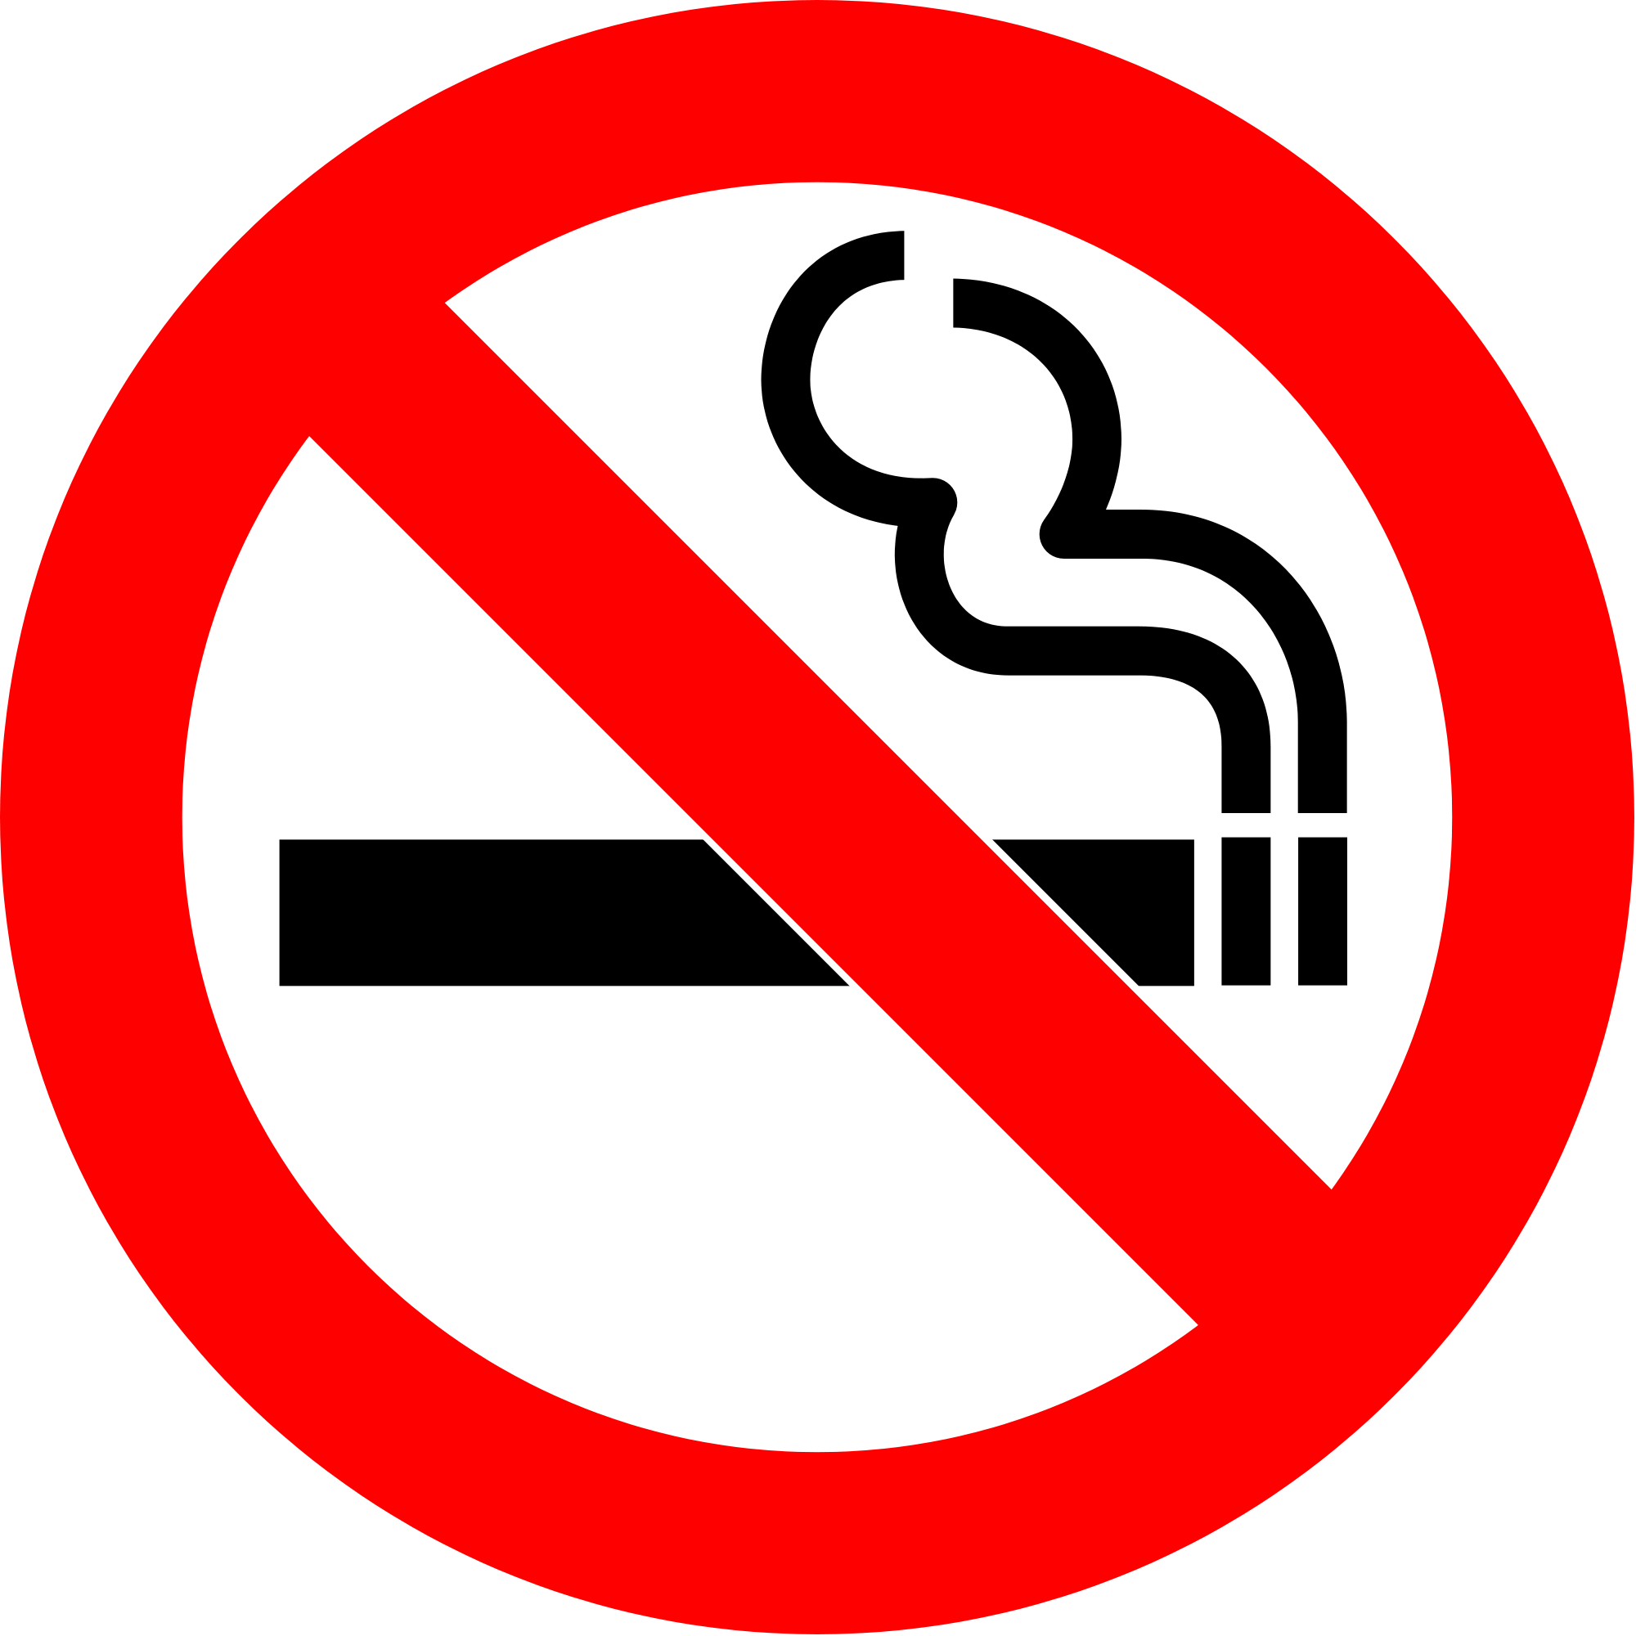

By

Pattie Sutphin, RN

Bryana Cox, RN

Earl Stracener, RN

Kayla Dalton, RN

Emily Butcher, RN

**How to Quit:**

* Counseling and Support
* Call a quitline (1-800-QUIT-NOW) for information and support
* Find a quit coach trained to help you quit and understand what you are going through
* Nicotine replacement therapy
* Chantix
* Nicotine Patch
* Nicotine Gum
* Combined Therapy
* Develop a quit plan
* Use quit programs such as the hotline
* Use the QuitGuide app on a smartphone

**Smokeless Tobacco: The Facts**

* The use of smokeless tobacco can lead to nicotine addiction and can cause users to progress to smoking cigarettes
* There is a high incidence of mouth, esophageal (the passage connecting the throat and the stomach), and pancreatic (a gland assisting with digestion and regulation of blood sugar levels) cancers
* Smokeless tobacco is associated with heart disease, strokes, gingivitis, gum disease, tooth decay, and tooth loss
* Smokeless tobacco can cause nicotine poisoning in children, and if used by women during pregnancy, increases the risks for early delivery and stillbirth

**Benefits and Risks of E-Cigarettes**

* Benefits
* E-cigarette aerosol contains fewer toxic chemicals than the 7,000 chemicals found in regular cigarettes
* E-cigarettes can help people completely quit smoking regular cigarettes.
* The e-cigarette can benefit non-pregnant adult smokers as long as they completely replace any other nicotine or tobacco products.
* Risks
* Some e-cigarettes contain nicotine and other known cancer-causing chemicals, which are harmful for the developing brain of adolescents and young adults.
* The flavoring of e-cigarettes is harmful to the lungs
* Some e-cigarettes have defective batteries that can cause fires and result in serious injuries

Brazier, Y. (2018, June 25). E-cigarettes: How they work, benefits, and risks.

CDC. (2019, January 9). Five reasons why calling a quitline can be key to your success.

Retrieved from https://www.cdc.gov/tobacco/campaign/tips/quit-smoking/quitline/index.html

*CDC*. (2016, Dec 1). Retrieved from CDC: Smokeless tobacco: Health effects:

https://www.cdc.gov/tobacco/data_statistics/fact_sheets/smokeless/health_effects/index.htm

 

1-800-QUIt-now

How to quit smoking